(Approx. 874 words)

How to Create a Chart in a Word Document
By Nancy DeMarte, 1st Vice President, Sarasota Technology User Group, FL
October 2016 issue, Sarasota Technology Monitor
www.thestug.org
ndemarte (at) verizon.net

Word is full of features and tools, but most of us use this popular application strictly for typing letters or other simple documents. There are many things besides text that can be created in a Word document. A lesser known one is a chart or graph. This feature is an excellent way to display budgets, trends, or other concepts that a collection of data can reveal. Here are the simple steps for adding a chart to Word:

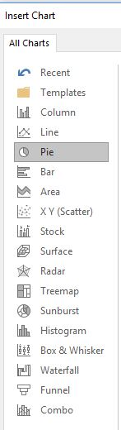
Choose a Chart type and enter your Data: Open Word and click the Insert tab on the ribbon, then Chart in the Illustrations group. You will see numerous types of charts in the left pane, such as pie, column, bar, and other innovative types. Moving your mouse over each chart type shows a preview of it in the right pane. When you find the one you want, click OK. (You can always change the chart type later.) At this point two items appear in your document: the chart you chose and a small data worksheet which contains sample data.

Let’s say you want to determine the proportion of your monthly budget that is spent for certain categories. In the first row of the data sheet, type over the sample header to add ‘Item’ and ‘Amount’. List some items and the average amount spent on them. You can use the keyboard arrows to move around within the sheet. The worksheet in Word displays only 20 rows and 10 columns, but clicking or holding down the arrow at the end of a row or bottom of a column gives you many more of each. So you can create a fairly large data worksheet, which is displayed above the sheet in your chosen chart. If your chart choice is not suitable for your data, click the chart and, in the ribbon, click the Chart Tools Design tab, click “Change chart type”, and make another choice.

Format the Chart: When you select the chart in the document, two important things become visible: four small tool icons to the right of the chart and the Charts Tools contextual tab, which appears on the ribbon and has two sections, Design and Format.

Formatting icons: The top icon, Layout Options, is a big help if you want to fit your chart within or next to a paragraph. Click the icon and choose the Square or Tight option to allow text to wrap around the chart. The Plus icon lets you hide or display items on the chart, such as the title or data labels. The Chart Styles paintbrush icon allows you to change the style or color of your chart. I find the Styles tab within this icon gives me some interesting variations on the way the chart can look. The Color tab lets you choose a new six-color scheme by clicking one of those shown. The last icon, Chart Filters, lets you select specific data from your worksheet to be included in the chart.

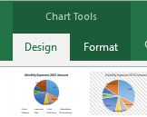
Chart Tools Design and Format tabs, which appear on the ribbon when a chart is selected, have much the same tools as the four icons to customize your chart. One good feature of chart creation in recent versions of Word is you can make a clean, professional chart without doing much customization. If you do want to experiment, the Design tab has some new changes you can make to a chart that you might want to try.

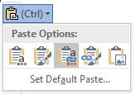
For Excel users: There is another way to add a chart to a Word document. If you use the Excel program in Office, you can set up your data worksheet and create your chart in Excel (Insert tab – Chart), copy it (Ctrl+C), and paste the chart into Word (Ctrl+V). The key skill here is choosing your desired paste option from the five choices that appear when you click the Paste Option icon. Options 1 and 2 will “embed” the chart in the document, which means it will become part of the document, but can be edited manually in Word. Option 1 will adapt the chart to the theme of the Word document, such as font and color scheme; Option 2 will keep the formatting that was present in Excel. Options 3 and 4 will “link” the chart to its data in Excel, so that when you change the data sheet in Excel, it will also change in the Word chart. Option 3 uses the destination (Word) theme; Option 4 keeps the Excel formatting. Option 5 pastes the chart into Word as a picture, which means the chart can’t be edited. Moving your mouse pointer over each paste option will give you its definition. If you want to use the same paste option in all future charts, click “Set Default Paste.”

Charts add a visual dimension that many of us find useful in understanding data. Although a Word chart lacks some of the more sophisticated features of Excel, it can work well for many kinds of charts a home user might want. Adding a chart to Word is not as complicated as it used to be.

